**LAB -2**

**TASK -1**

**CODING :**

using System;

using System.Collections.Generic;

using System.Linq;

using System.Text;

namespace oop1

{

class Program

{

static void Main(string[] args)

{

int a, b, sum;

Console.WriteLine("Enter First Number : ");

a = Int32.Parse(Console.ReadLine());

Console.WriteLine("Enter Second Number : ");

b = Convert.ToInt32(Console.ReadLine());

sum = a + b;

Console.WriteLine("the sum is {0}.", sum);

Console.ReadKey();

}

}

}

**OUTPUT :**

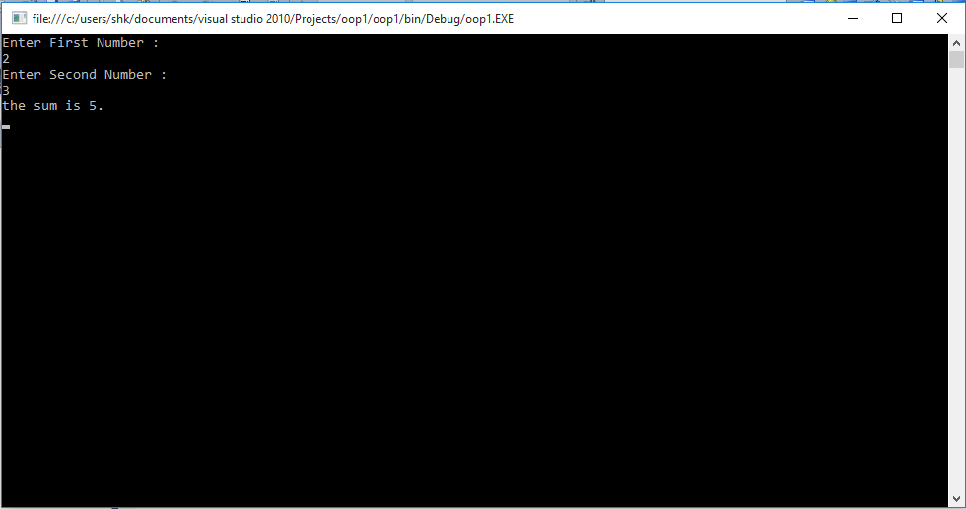

**TASK -2**

**CODING :**

using System;

using System.Collections.Generic;

using System.Linq;

using System.Text;

namespace oop2

{

class Program

{

static void Main(string[] args)

{

int a;

Console.WriteLine("Enter an Integer : ");

a = Int32.Parse(Console.ReadLine());

if (a % 2 == 0)

{

Console.WriteLine("Number is Even");

}

else

{

Console.WriteLine("Number is Odd");

}

Console.ReadKey();

}

}

}

**OUTPUT :**

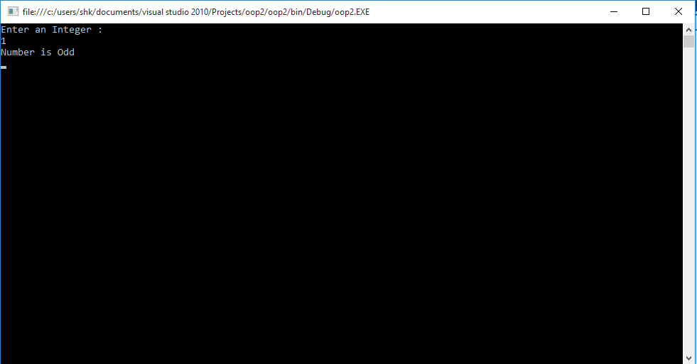

**TASK -3**

**CODING :**

using System;

using System.Collections.Generic;

using System.Linq;

using System.Text;

namespace oop3

{

class Program

{

static void Main(string[] args)

{

int a, b;

Console.WriteLine("Enter First Number : ");

a = Int32.Parse(Console.ReadLine());

Console.WriteLine("Enter Second Number : ");

b = Int32.Parse(Console.ReadLine());

a = a + b;

b = a - b;

a = a - b;

Console.WriteLine("First Number : {0}",a);

Console.WriteLine("Second Number : {0}",b);

Console.ReadKey();

}

}

}

**OUTPUT :**

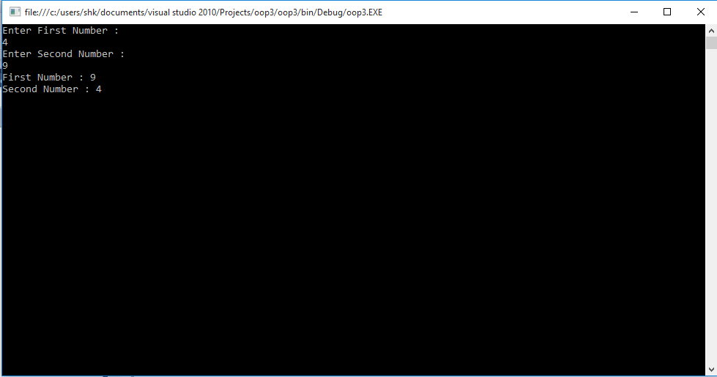

**TASK -4**

**CODING :**

using System;

using System.Collections.Generic;

using System.Linq;

using System.Text;

namespace oop4

{

class Program

{

static void Main(string[] args)

{

long a=1, n;

Console.WriteLine("Enter an Integer for Factorial : ");

n = Convert.ToInt32(Console.ReadLine());

for (int i = 1 ; i <=n ; i++)

{

a *= i;

}

Console.WriteLine("Factorial : {0}" ,a);

Console.ReadKey();

}

}

}

**OUTPUT :**

